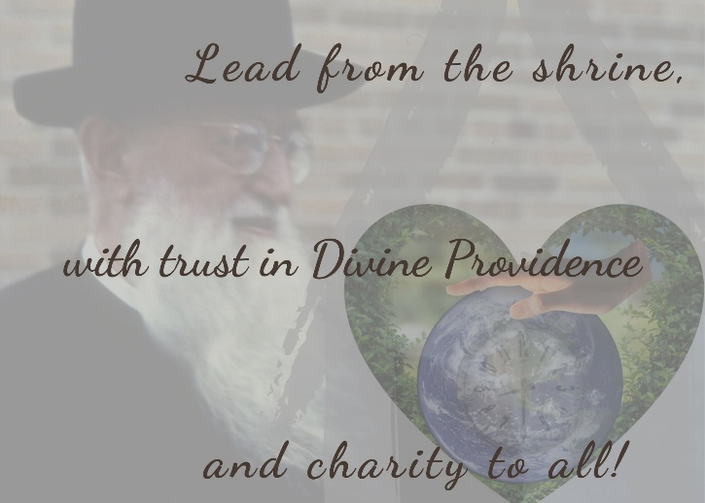

Sermon from Father Pushpa - October 10, 2020
2020 October Convention – Online Session 2
Motto: Lead from the shrine with trust
in Divine Providence and charity to all!

The motto and the readings [for today] fall into place. We did not choose these readings. When we look at the combination of the readings and our first meeting in search of the motto on September 12, we see the picture that is portrayed before our eyes. That day was the feast of the Holy Name of Mary. The image of the shrine and of the Blessed Mother were before us.
When you think of the shrine, what comes to mind? A beautiful place, the picture of the beautiful and peaceful smile of the Blessed Mother! When we look at her, we know that she cares for me, she listens to me. In her presence, I am at home. Those are normally the feelings we have. Those are the feelings we attribute to the shrine. It is what we experience across the globe in our shrine. It refers to the fundamental sense of home we have in the shrine. But if you look into history, how was the shrine in the beginning? It was a place for tools, outside, to be worked exteriorly. Then, it dawned on Father Kentenich to motivate those young men to clear the room, to make space for the Blessed Mother, and to invite her. When we look at the history of the Original Shrine and think of today, 10-10-2020, the numbers sound nice! If you write today’s date, you see that the numbers are repeated. It means history repeats itself. Today’s date reminds us that history repeats itself. If you want us to be renourished by the grace from the shrine, we need to go back to the origin.
[Back then,] everything came from shambles. The young men cleared it up and made that space available to the Blessed Mother to come and dwell there. And from there, she distributes her graces.

It is important to remember that history, but also to constantly do likewise. When we think of the phrase from the shrine… it is necessary for every generation to, not only to immediately think of the graces but also of the steps taken prior to the founding act. They cleared the clutter. Today more than ever there is one phrase which I have been pondering: the plague of political polarization, or of any polarization, particularly in this time of the pandemic… These are all the ideas that tend to stress our minds. Clearing up something exteriorly is much easier. But clearing something that is in the mind is harder. Because only you know what goes on in your mind. That is exactly the voices of time in which we live. What is going on?

Even a next-door neighbor, even someone living in the same house as you may not know what afflicts you! To become aware of this, to become aware of what is going on is harder. What do I need to do in order to make more space for God and for the Blessed Mother? That is essential for every age, for every generation, even much more at present than in the past. But how do we do that? Father Kentenich had a way of doing this. He invited; he led the students and inspired them.

Let’s think of our motto and the way in which we came to formulate it. Let’s take the letter L. Lead! What does that mean for us in light of our father and founder, in light of the Blessed Mother, and the devotion we have for them? We happily come to the shrine, and happily we go to our home shrine, because when we sit there we tell Blessed Mother all that we have in our mind. When we come, we do not hear the Blessed Mother telling us: “Hey, you did this and this…” If she would start speaking back to us, would we come back so happily? No! She is there to listen to us. She wants to know what is going on in you. “I am there for you!” The same attitude was reflected when we heard about the people who met our father and founder. When he came here to Milwaukee during his time of exile, not knowing when he would go back, he showed interest in the people that came to him. He listened to them! That is what made them say: “He was there for me!”

People felt at home in his presence! That is something necessary for us. If we are leaders, who want to lead and be active, listening is so vital! This was the case not only back then; this is so necessary in our modern days. We know it from our times, from our own families, from our own communities.

What happens around us? Our attention span is becoming shorter and shorter. That is where we find our mission, as leaders of the Schoenstatt Family! We need to come back to the original art of listening. That is what the Blessed Mother teaches us. It is what Father Kentenich teaches us, too. He was not sitting there saying: “I was a fatherless child, how am I going to help others?” No, he told himself, “I am here for you!” That type of listening is essential in our time!

Then, [the letter] E. It is not just about listening. You need to have empathy for the person in front of you and know what is going on. When I come to certain people, when I am in the presence of some people something happens in me interiorly. Becoming aware of that change, we feel like coming back to that experience. That is something unique, especially for us as Schoenstatt Family. We find this experience in the shrine and in the people we encounter. In the way Father Kentenich listened, people not only felt well, they also experienced that he gave them hope. This can transform me. This is the empathy that plays such a crucial role in our time. That is what it means that in this shrine, in the presence of any encounter with our founder, people always to come back to it. When we sense that someone is able to feel along with us, we are drawn to come back to that person, to that place. This is something unique. This is an art that we can learn. It demands more attention in our modern world than it did before.

A: Acceptance and appreciation! Accepting a situation! This means to see: “This is the condition; this is the situation!” Then, to be able to appreciate it. Finally, to say: “I can move on!” How do we see this in the life of Father Kentenich? Yesterday, someone asked the question: “As a fatherless person, how did he become a father to many?” I am sure in his early age it must have been hard to maneuver things around. Before his ordination we see him going to his dad and trying to speak with him – a move that was not easy. It was painful, but even knowing the situation, he does not regret things and says: “I didn’t have a father therefore I can’t become a father.” We see in him the acceptance of the situation. “With the relationship that I foster with the Blessed Mother I can overcome [any situation].” This also means to have appreciation for the situation. It allows us to move on. This capacity is essential for us as leaders and as Schoenstatt Family. Accept and appreciate! [Father told himself:] “God, if you have a plan, you have the time, and I am trusting in you.” With that attitude, he felt at home in the presence of the Blessed Mother. He could radiate that to other people. We are here to accept our circumstances and appreciate what God sends us.

With the D comes the whole concept of the Gospel reading and the last part of our motto. What is the last part of the very short Gospel? “Rather, blessed are those who hear the word of God and observe it” (Lk 11:28). We know – at least I can speak for myself: The gap between what you know and what you do every day becomes larger and larger. We know many things and we know the right thing to do. But from knowing to doing, is not that easy. Some may say: “What is your problem?” Maybe it is only my problem or a problem of this generation. There is a gap between knowing and the behavior. But this has been a problem [for ages]. Sometimes when I read today’s Gospel, I see that it has been a problem already from that time. The behavioral deficit is the problem; the knowledge deficit is not. How do we bridge that gap? If we do not bridge that gap, we become more annoyed, more angry, more restless. That is what I have seen. This is what God is also telling us.

It is one thing is to know something – for example, when we have a motto, we see that we are called to trust in God in Divine Providence and be at peace with what Divine Providence sends us. We receive the invitation to be among those who do the will of God, not among those who know but do not do it.
I wish that we, as leaders with all the limitations that we have, that we know we have, that we may continue to strive to do the will of God. I know from the experience of the Blessed Mother, that this is what she did. She listened! Even when there are confrontations, at the end of the day, we have to say: “Let it be done according to your will.” This is what gave her that special place [in the plan of God]. We can say the same of Father Kentenich. He, too, said, “You have a plan, I trust in you. Let that happen.” It is the same with the person of Jesus Christ. [In his passion] he looks at [the situation] sweats blood and says: “I do not want this. But if you want this to happen…” (cf. Mt 26:39). This is something unique. In this regard, we need to let our motto speak to us, especially in our modern days when people just echo: “I want to find my voice being heard, I want to find my ideal, I want to live!” That is fine, we should find it. Fine! But once we find it, we should also bring our inner voice back in alignment with the one who created us, in alignment with the one who called us. This type of concept is missing. Without that concept of divine love, we are missing something. In that regard, we are so rich now-a-days, compared to 40, 50 years ago. Do we really have inner peace? No. That is why we may be prosperous, and even luxurious in many ways, but the inner loneliness is still there, and it kills. Coming back and saying, not only my will and desire, but let your will be done. Stepping into this reflection is coming to the last part of the motto. If we have this then we can divide [the word] lead into four parts: Listening, Empathy, Appreciation and Acceptance, and Do what God wants from us.

These ideas are bound to the graces we receive from the shrine: being at home, feeling at home, but at the same time, the inner transformation. Because I am in the presence of God, because I am under the care of Divine Providence, I have something to do, I have to move and have charity, today more than any other time. During the time of pandemic, we realize that there are things we would like to go back to, but the times settle in. The voices of the time call us to action and to move forward, to greater listening, greater compassion, greater acceptance, also greater appreciation. At the end of the day, it means to do the will of God, not just fulfill my desires, not just accomplish what I want but to seek one another and look out for each other. In that listening, we find the voice of God and move on to do it. Our contribution could be to transform our lives and to transform the lives of those around us. I would like to leave you with that thought.

What I see in this country of America is that it is known for its optimism. After 13 years we have a new Schoenstatt Father, Father Jeff, from here, from this country. It reminds me of a quotation from Rabindranath Tagore, the only Indian poet that I know Father Kentenich has ever quoted. He said: “Every time that a child is born, it reveals that God is still in love with the world.” Every time we have a new vocation it is a great joy for us. You wish that this occasion would happen more often. That the gap between ordinations would lessen. We need more priests; that is our desire.

I wish that America as a country of great opportunities, a land of optimism, but at the same time a land of great political polarization – as it is plaguing us at present, and around the globe, too – that we can hear the call, the invitation. We cannot sit back. We need to lead, listening, actively expanding the circle of our shrine, showing empathy, acceptance, and appreciation, and doing the will of God. This is how the Blessed Mother did it, and our father and founder, too. As leaders, we want to follow them in all that we are and do. Let the grace of God flow through us. For that, we ask that we be given the grace of God and pray for every leader in this country within the Schoenstatt Family.

Questions for discussion:

- What interior obstacles do we need to remove in order to become good listeners, who can approach others with empathy and appreciation?
- What can we learn from the life of Father Kentenich in view of the manifold challenges we face in our time and age? Mention at least three points that we can learn from his character and history.
- As leaders of the Schoenstatt Family, where are the difficulties for open dialogue and sincere acceptance of other’s point of view or voice?
- How can we educate ourselves toward greater docility to do God’s will in our lives?

Phrase spoken by Father J. Kentenich on October 1929: “In the shadow of the shrine the history of the Church and world will be co-determined for centuries to come.”

